Practical 8
Definition : Clean real-world datasets by handling missing values, duplicates, and inconsistent data across platforms.
Outcomes / Learning : This experiment demonstrates fundamental data analysis and visualization techniques using Excel, including data creation, cleaning (removing duplicates), summary statistics, and missing value imputation.
Required Tool : The Experiment was performed using a Microsoft Excel Environment which is crucial for performing such Activities.
Working : The Experiment successfully Identifies & Removes Duplicate Values, Replaces Empty Slots with The Mean Values of the corresponding Row, Trims Extra Spaces, Formats Dates and Duplicates Original Sheet.

For Identifying and Removing Duplicates :
Step 1 : Use Conditional Formatting → Highlight Cell Rules → Duplicate Values... to instantly color-code and visually find all the duplicate entries in your selected range.
Step 2 : Go to the Data tab and click Remove Duplicates. In the dialog, select the column(s) (e.g., 'Age', 'Gender') that must match for a row to be deleted, and click OK to purge the redundant rows.

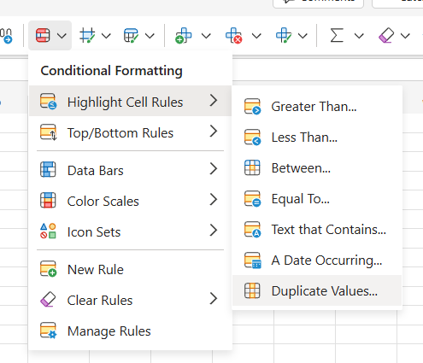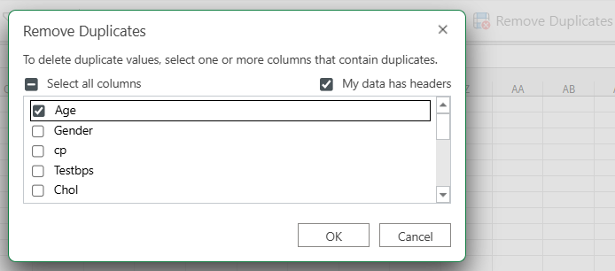

For Handling Missing Values :
Step 1 : Calculate the Mean :
  - For the column containing missing data (or empty cells, which are to be treated as NAN), calculate the mean value. This value will be used as the replacement.
  - (In your example, the mean value calculated in the last row for the first column is 54.02439024).
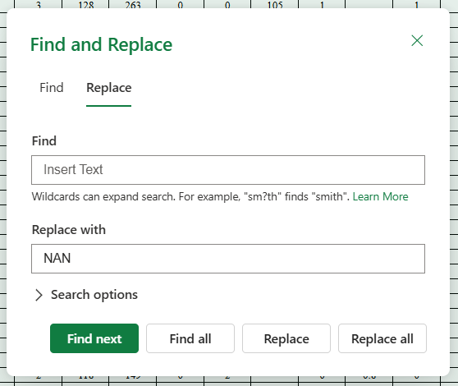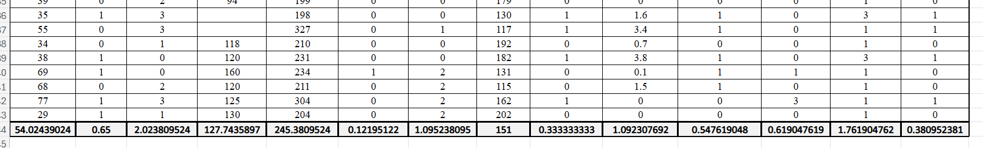
Step 2 : Replace Missing Values with the Mean :
  - Use the Find and Replace function. In the "Find" field, enter the identifier for the missing data (e.g., the blank space or the text NAN).
  - In the "Replace with" field, enter the mean value calculated in Step 1 (e.g., 54.02439024).
  - Click Replace All to substitute all missing or NAN entries within the selected data range with the column's mean.
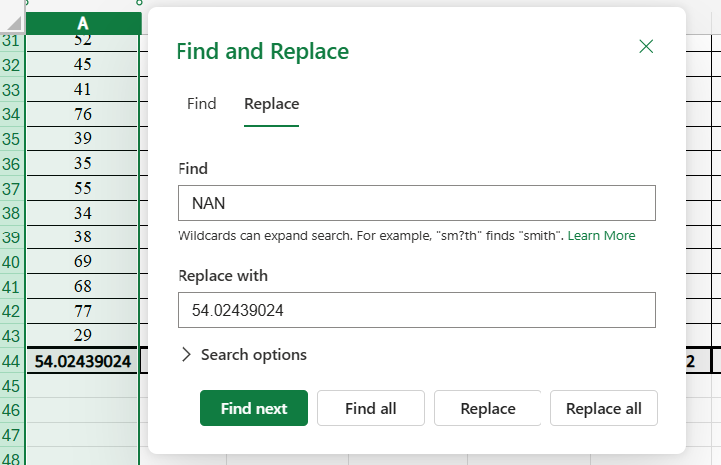
For Trimming Extra Spaces :
Step 1 : In an empty column next to your data (e.g., cell B2), enter the formula =TRIM(A2) (adjusting A2 for your cell) and then fill the formula down to clean the entire data set.
Step 2 : Copy the newly trimmed column and use Paste Special → Values to paste the clean text directly over the original, uncleaned column.
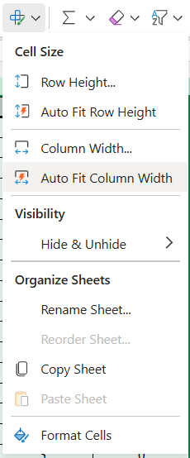

For Formatting Date :
Step 1 : Open Format Cells :
Right-click the cell(s) you want to format and select Format Cells (or use the equivalent option shown in your second image under the 'Organize Sheets' section).
Step 2 : Select Date and Type :
In the Format Cells dialog box, ensure the Number tab is selected, choose Date from the Choose Category dropdown, and then pick the desired Type (date style) from the list.
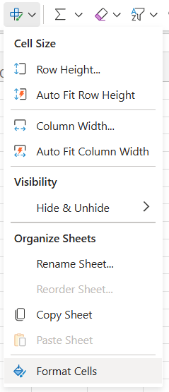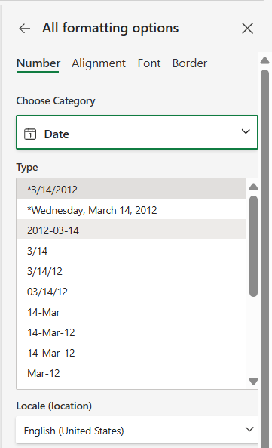
For Formatting in Order :
Step 1 : Click the filter/dropdown arrow next to the column header 'Age' (Cell A1).
Step 2 : Select a sorting option from the menu, such as 'Sort Smallest to Largest' (A to Z) or 'Sort Largest to Smallest' (Z to A).
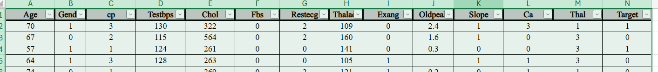
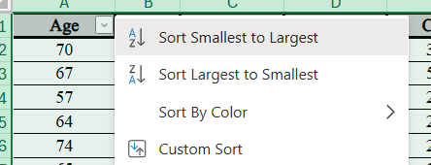
For Duplicating Sheet :
Step 1 : Right-click on the name of the sheet you want to duplicate (e.g., "Main Sheet").
Step 2 : From the context menu that appears, click Copy Sheet.

